How to Build an US-guided D&E Model

Supplies
- 64oz Glad Tupperware
- 3” x 4” PVC coupler
- Xacto knife or box cutter
- Gorilla glue contact adhesive
- Knox gelatine
- Biscuit cutters – for this model, you will need the 1 7/8” size. This set of biscuit cutters allows you to use different cervical “dilations” for the model
  - Alternative cervix: poured silicone into cervix mold
- 36” balloons
- Foam stress balls – optional, only used with biscuit cutter cervix
- Silicone kitchen funnel - 3.4”
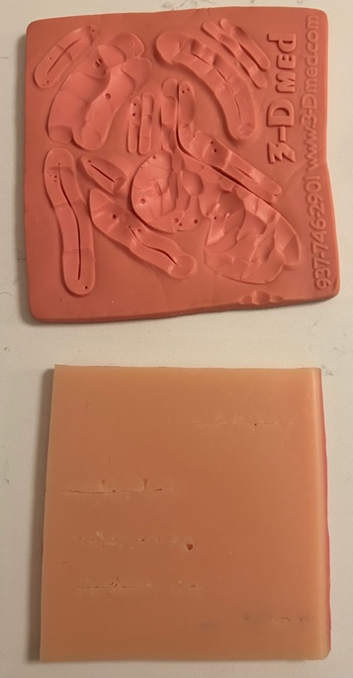
- Diving starfish – cut the arms off to serve as limbs. Can leave one with some central piece on it for spine (see red starfish arm in picture below)
- Calvarium options:
  - Refillable easter eggs
  - 2” sized tomatoes (~16 weeks) or Roma tomatoes (~20+ weeks), wrapped in aluminum foil
  - 3D printed
- Low loft polyester batting – if you can find smaller amounts or get a yard from a local fabric store if they have it. Cut into 5” oval and soak in water
- Silicone suture pads -OR- ballistic gel pads x2
  - Use what you may have on hand, or these with the fabric backing pulled off
  - **NB: ensure pads are echolucent
  - If you choose to use ballistic gel instead of silicone suture pads, purchase:
    - Ballistic gel materials:
      - Ballistics Gel (About 0.5L)
      - Crockpot (not a pressure cooker)
      - Flat metal baking tray or plastic cafeteria tray
      - Oven mits
      - Large metal cooking spoon for scooping the liquid ballistics gel from the crockpot
- Nexplanon “arm” model

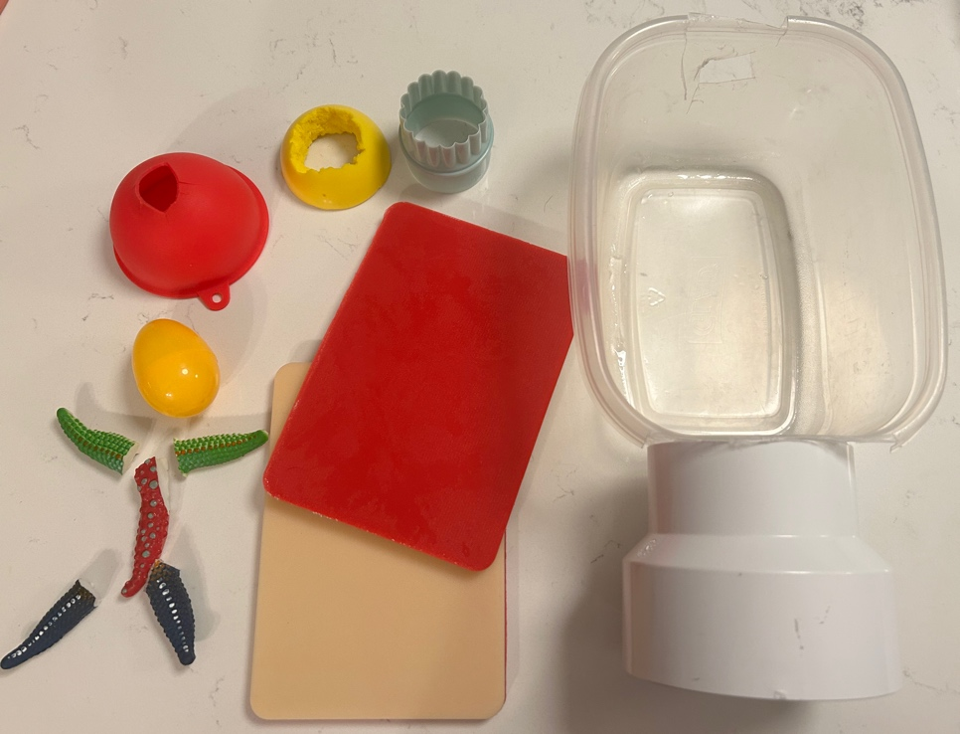

Ballistics Gel Skin (2-3 hours) – this can be done several weeks in advance
- Take your ballistics gel and break it up into small pieces (about the size of ping pong balls)
The following steps should be done in a well-ventilated area
- Place the ballistics gel pieces into the crockpot and set it to low (if you set it to high, you risk burning the gel and releasing toxic smoke)
- Once the gel is fully melted, move outside or to a well-ventilated area as there may be smoke; it is best to transport this on a cart and not by hand
- Pour the gel into the tray on a flat surface; it will take some time to solidify, but at this time it can be brought back inside to cool
- Cut ballistics sheet in half once cooled, making sure one will fit on the bottom of the tupperwear and one is larger than the top so that it hangs over the edge

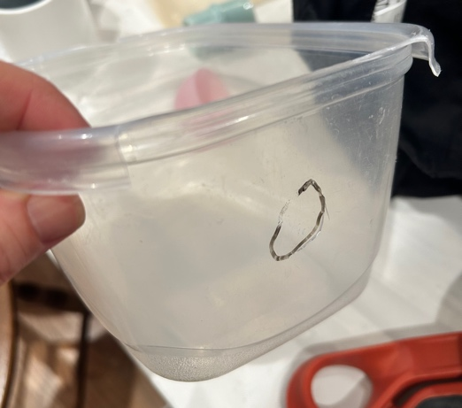
How to assemble the model
- Cut the lip off one end of the Tupperware and make a 5 cm hole in the side
- Glue the 3” end of the 3” x 4” PVC coupler to the Tupperware using the Gorilla glue according to the instructions on the tube
- Cut the bottom of the funnel off at the base of the bowl portion and make 4 short slits (~1cm) from the cut edge to make a plus sign
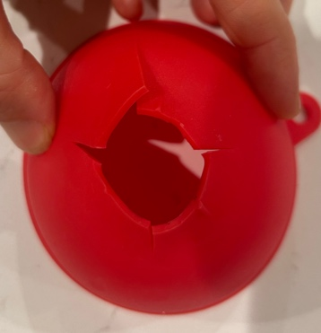

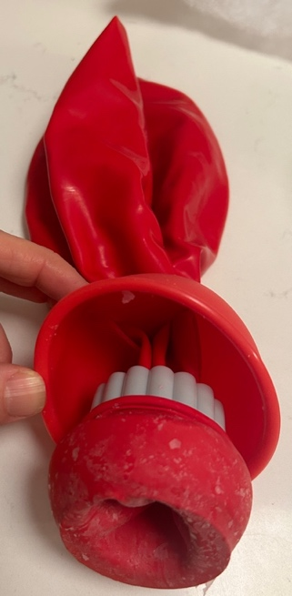
- Cut a stress ball in half and carve out the middle to accommodate the diameter of the biscuit cutter. Place the stress ball ring around the biscuit cutter. This is the “cervix” where the tenaculum can be placed if desired. This step is optional if you want to use the model without a tenaculum
  - Alternatively, can use a silicone cervix and omit the biscuit cutter and stress ball
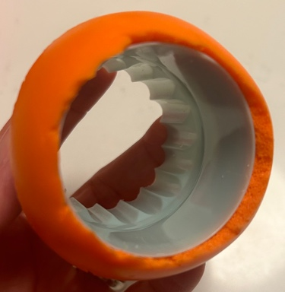
- Place the neck of the balloon through the funnel and the 1 7/8” biscuit cutter. Stretch the mouth of the balloon over the biscuit cutter/foam ball cervix or silicone cervix.

- Feed the balloon through the “vagina” PVC coupler and into the Tupperware. Pull the balloon until the cervix assembly sits tightly in the vagina.

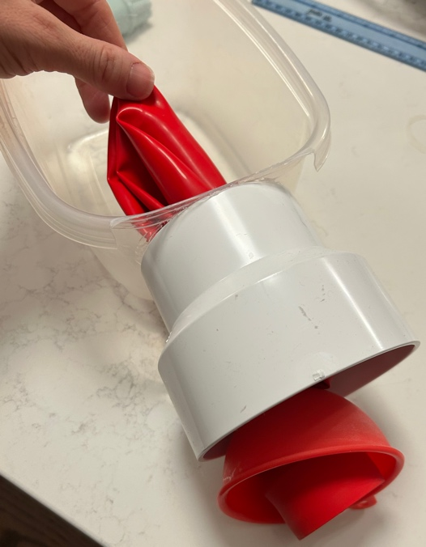
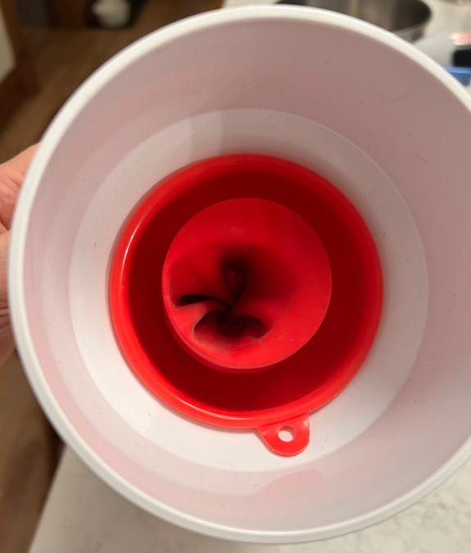
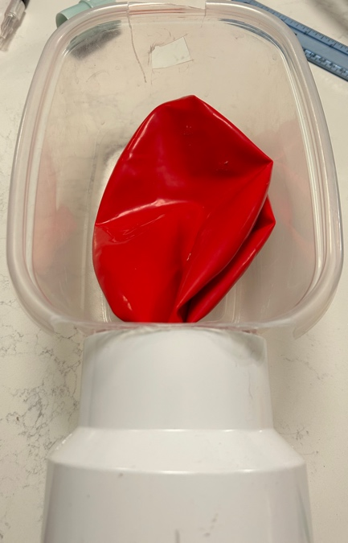
- Set the funnel into the coupler – this should be a tight fit

- Load in the “limbs” and “placenta” – squeeze excess water from placenta prior to putting it into the balloon. If using tomatoes for calvarium, load in now.
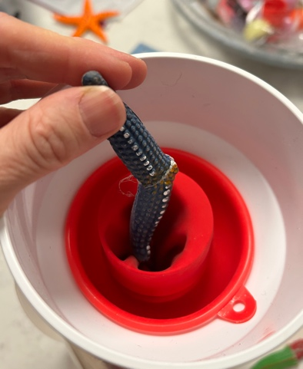
- Prepare the Knox gelatine. Bloom three packets in 1.5 cup cold water for 1-2 minutes. Add 4.5 cups boiling water and stir to dissolve. You should have 6 cups total

- Put the hot gelatine in the fridge for about 45 minutes until it’s cool enough to handle.

- Submerge a refillable easter egg in the gelatine. Try to get as much air out as possible. It’s ok if some gets in during the transfer process, you can fix this by grabbing the egg through the balloon and submerging it in the balloon

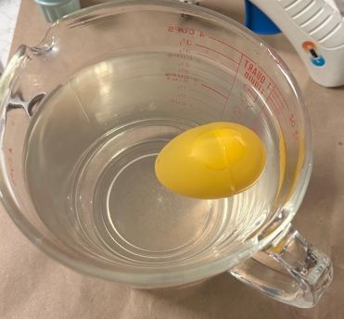
- Pour in about 4-5 cups of the gelatine into the balloon. Add the easter egg and then the rest of the gelatine.
  - Submerge the egg again to allow any air to escape

- Set the model up right in the fridge to set overnight

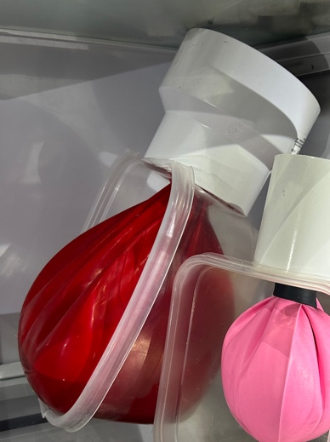

Day of Simulation Assembly
- Place the smaller ballistics gel sheet or suture pad in the bottom of the Tupperware. Add a generous layer of US gel and allow the balloon to rest on top
- Generously gel the remaining space around the balloon filling the tupperwear to the top. Try to smooth any wrinkles in the balloon or fill wrinkles completely with gel. Place the second ballistics pad or silicone suture pad on top
- Rest the “vagina” on the Nexplanon arm for Trendelenberg effect and easier access
- Add a generous layer of US gel on the top of the top ballistic gel sheet or suture pad
- You’re now ready!
  - You will need long forceps to reach the back of the Tupperware. Ring forceps are too short
  - Put a chux down – there will be spillage of gelatine with removal of pieces
  - The gelatine will feel firm when first out of the fridge. It will get a little softer when it sits at room temp.
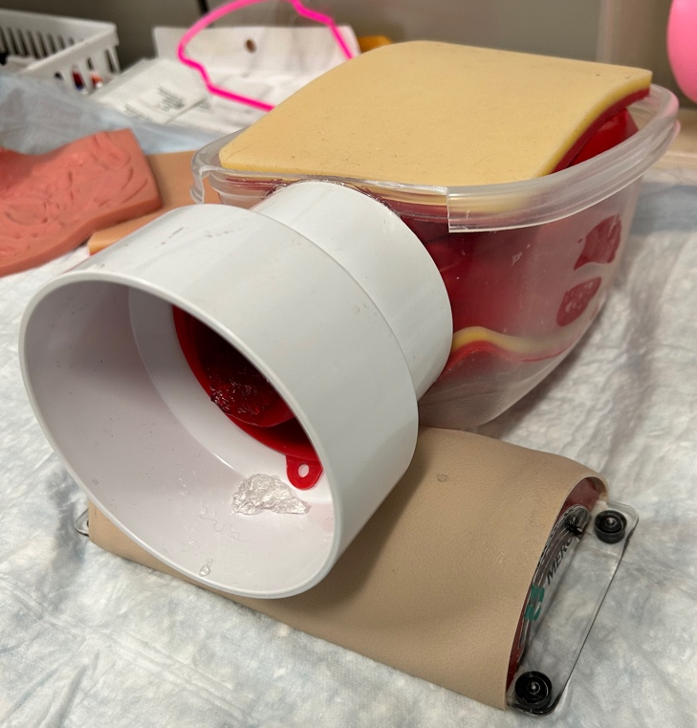
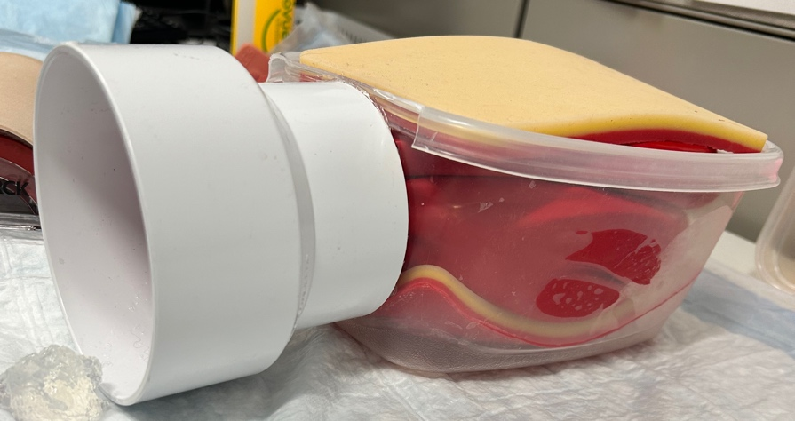

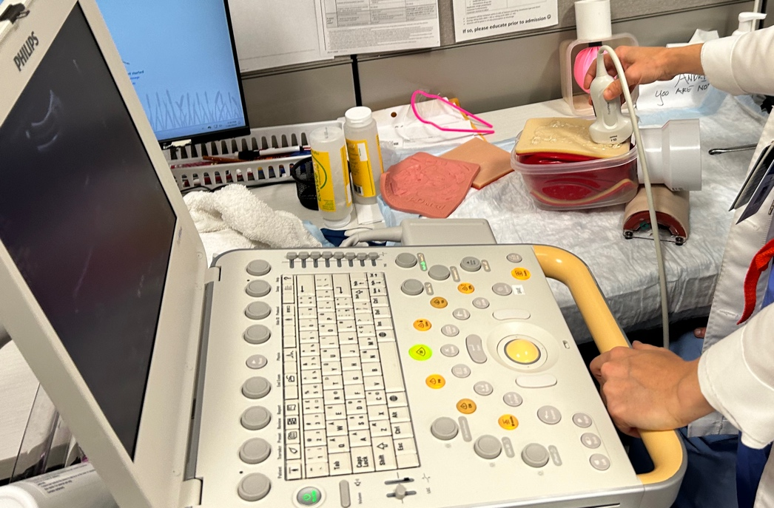

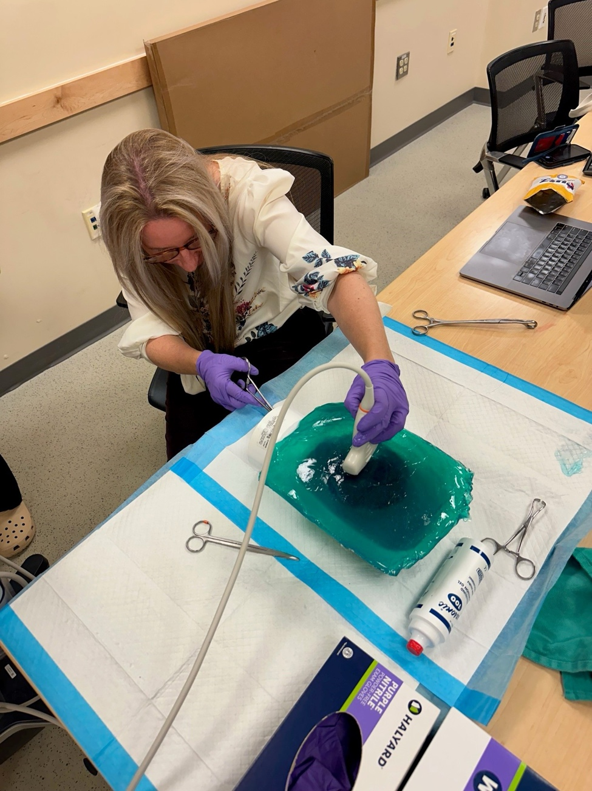
Ballistic gel set up

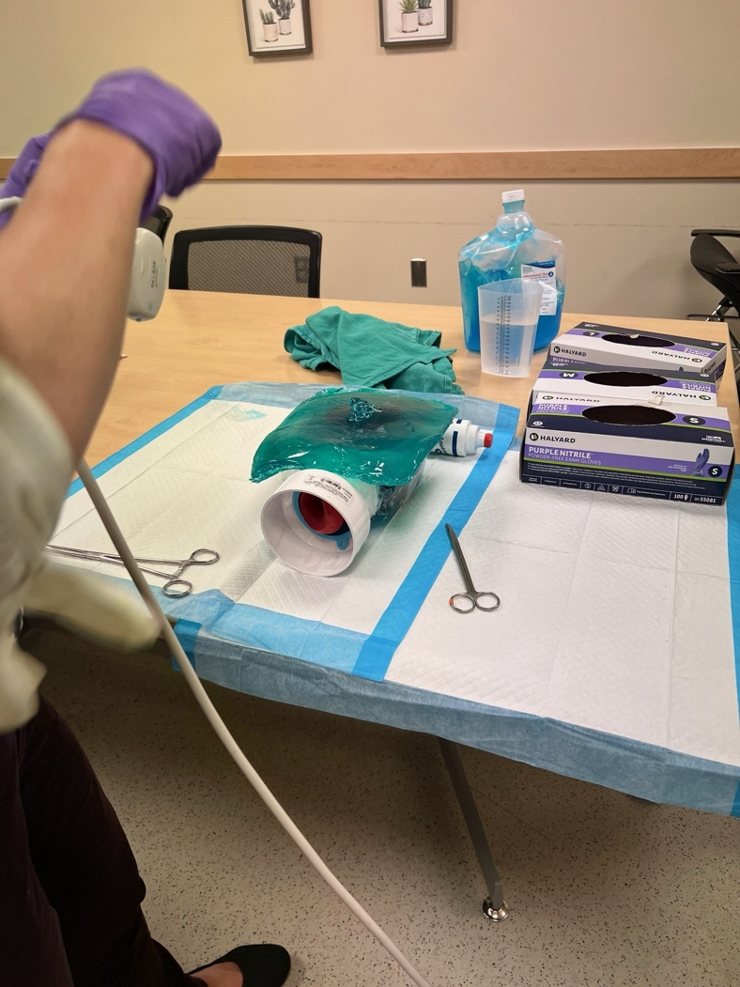

Some Images

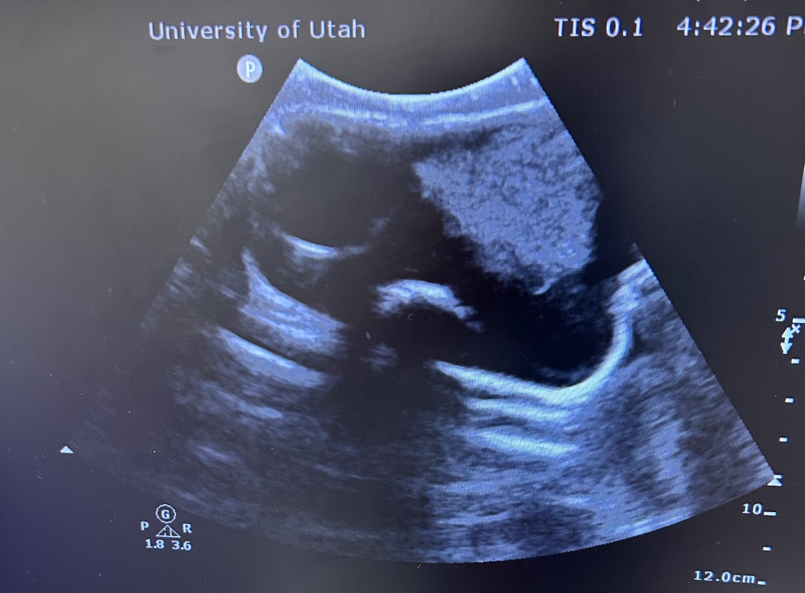
Circle = placenta
Single arrow = cal
Double arrow = limb

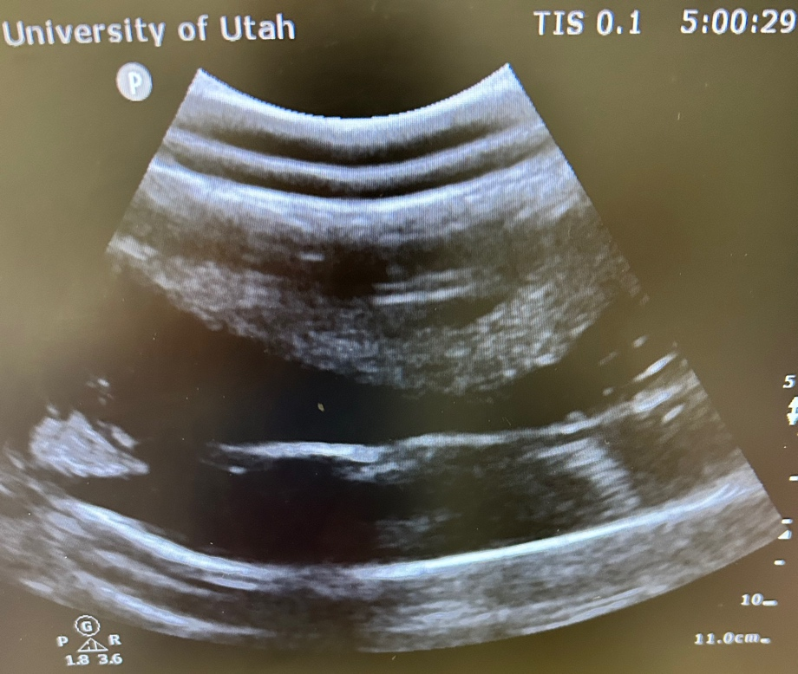
Circle = placenta
Single arrow = forceps tip
Double arrow = limb

